Pockies Celebrates Ten Years of Comfort with New Year's Eve Bash at the RAI

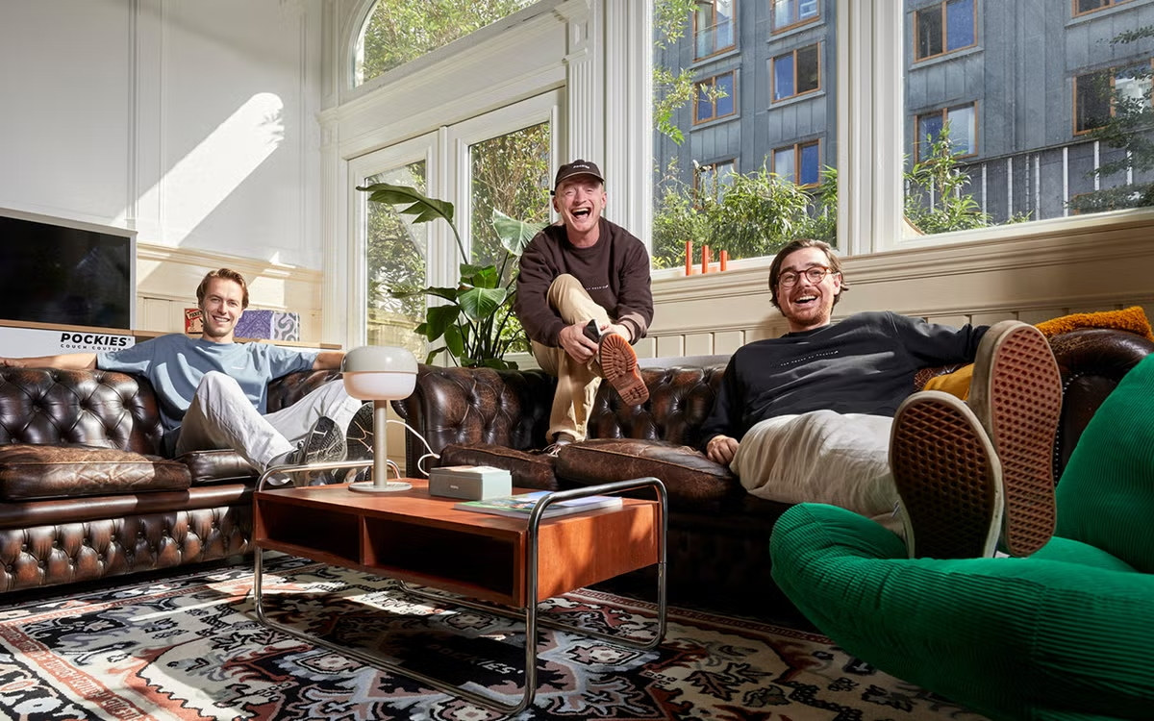

From Experiment to Ten Years of Success
When Michiel Dicker and his friends developed the first boxers with pockets in 2015, they couldn’t have predicted what would follow. The initial stock sold out within weeks, marking the start of an expansion into a complete range of loungewear. The philosophy of 'Couch Couture' — comfort as a lifestyle — resonated with consumers seeking an alternative to traditional loungewear.
Over the past decade, Pockies has expanded their range to include pajamas, joggers, T-shirts, and accessories. The brand has distinguished itself by adding functional details to comfortable clothing, a combination that gained even more popularity during lockdown periods. The inviting aura of comfort that the brand exudes has since developed a loyal customer base.
Ending the Year with a Celebration
"We want to end the year just as we started: with a wink and a focus on enjoying together," says Michiel Dicker, spokesperson for Pockies. "The event at the RAI is our way to thank everyone who has grown with us over the past ten years— from the first customers who took a chance on our boxers with pockets to those who now sport our entire collection."
The anniversary event on December 31st promises to be a mix of music, entertainment, and of course, an abundance of comfort. Pockies will reveal details of the program in the coming weeks through their channels. With this celebration, the brand hopes not only to look back on a successful decade but also to look forward to the future of comfortable fashion.

Over: Pockies
Pockies started in 2015 as a fun experiment among friends when they created the very first boxers with pockets. Much to everyone's surprise, the initial batch sold out rapidly, paving the way to build their brand around their vision for Couch Couture. Pajamas, joggers, T-shirts, cozy socks, and more followed, as they made it their personal mission to spread comfort all over the globe.

Newsroom
Bekijk het volledige persbericht inclusief meer foto's en video's in onze Newsroom.
Bekijk het volledige persbericht
Bekijk alle voorgaande persberichten

Contact informatie
Naam: Michiel Dicker
E-mail: michiel@pockies.com
Telefoonnummer: 06-21715581

